## Oct 26, 2023 | [data play](https://www.google.com/calendar/event?eid=M25iaGhpcnBuNWFoZWJxMmNqdDhobWhlaG4gZ3VvZmFuZy5tYS5nckBkYXJ0bW91dGguZWR1)

Attendees: [J H](mailto:jane.han.gr@dartmouth.edu) [Freya Ma](mailto:guofang.ma.gr@dartmouth.edu)

**Meeting Agenda**

* Discuss and share the **current progress**
* Discuss next steps and **future goals and steps**

**[Vision] Copied from proposal**

**Aim 1:** **Visualization of insomnia symptomatology in adolescents by subgroups**

1.1. Visually identify distinct subgroups among adolescents based on demographic variables (e.g., **Age, Race**) and their distribution on the **GCTI, ASHS, ASQ** battery tests.

1.2. Utilize data visualization techniques (e.g., **heatmap analysis**) to depict the relationship between identified subgroups and psychological factors. Provide an intuitive representation of how diverse psychosocial factors contribute to varied sleep patterns in adolescents.

**Aim 2:** **Statistical Analysis of Sleep Quality and Habits in Adolescents**

2.1. Use **sleep quality** to predict **mental health and habits** among adolescents with regression analyses.

2.2. Investigate if the interaction effect of significant predictor factor(s) above and the race factor is statistically significant.

**Completed task today**

* Confirmed and shared progress with Ashlee
  + On the right track! Yay! (some group have not started… oh no!)

**Meeting Notes**

* **Code** 
  + Incorporate the techniques (Excel/R) we learned in class
* **Presentation**: **20 minutes** per group
* Sample presentation, write-up, maybe rubrics could be provided after TA-Carly discussion
* **Write-up** is also required for submission
  + Could talk about all documentations and steps/appraoches we have in details

**Current Status**

* Jane : pearson correlation between ISI - GCTI - significant

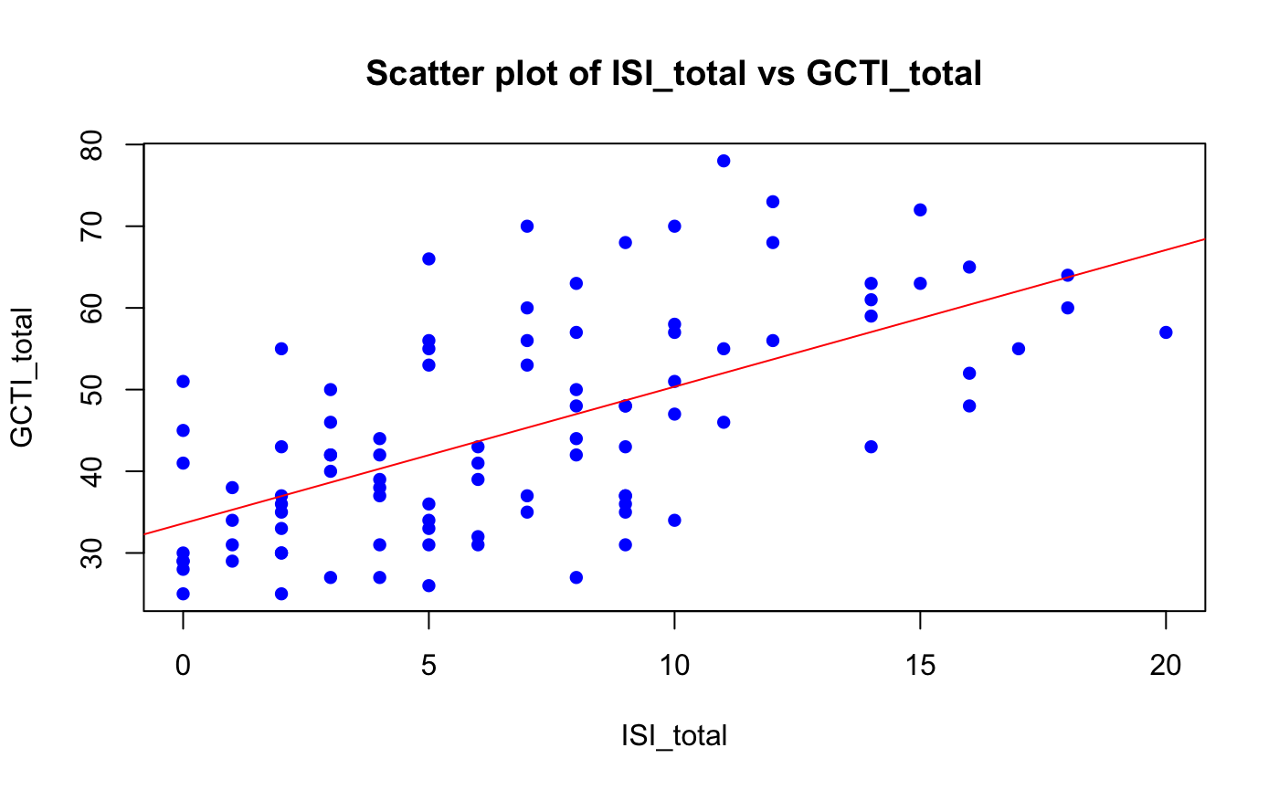

Pearson's product-moment correlation

data: data$ISI_total and data$GCTI_total

t = 7.6112, df = 93, p-value = 2.181e-11

alternative hypothesis: true correlation is not equal to 0

95 percent confidence interval:

0.4776306 0.7299362

sample estimates:

cor

0.6195352

* Freya : race and other columns exploratory analysis
* Jane note on Freya’s rmd

Jane Question:

red why black native hawaiian no block (quarter error bar?)

blue american-indian, black, native hawaiian

-> not enough data points?

Future possible analysis

[] which of those scatter plot and pearson corretions are significant

[] we could also do heatmap plot for everyone - Jane will do

[] then compare also among groups so 5 heatmap - see if Jane can do

[] then RSA analysis? - think more by Jane

* Joseph: (feel free to add in)

**Next steps**

* Make the heatmap of different columns - Jane (both normalized and original)
* Age grouping exploratory analysis - Freya
* (feel free to add in) - Joseph

**Final submission documents**

* Presentation 20 minutes
* Write-up

**Task, Action steps, and deadline**

* **Tuesday, Oct.31st,** 4pm-5pm
  + Finalize Aim #1
  + Continue to work on Aim #2
* **Thursday, Nov.2nd,** 4pm-5pm
  + Draft one presentation
* **Tuesday, Nov.7th, 4pm-5pm**
  + **Ask for Ashlee’s advise and feedback on our presentation**
  + Practice Presentation
* **Thursday, Nov.9th:** 
  + FINAL PRESENTATION
* **Future meetings:** 
  + ~~Thursday, Oct.19th, 4pm-5pm (or 4:30pm)~~
  + ~~Thursday, Oct.26th, 4pm-5pm (or 4:30pm)~~
  + Tuesday, Oct.31st, 4pm-5pm (or 4:30pm)
  + Thursday, Nov.2nd, 4pm-5pm (Draft one presentation? & TA feedback)
  + Tuesday, Nov.7th, 4pm-5pm (**Practice Presentation**)
  + **Thursday, Nov.9th: FINAL PRESENTATION**